SQL (Major)

22-05-23

1. Create a table “Station” to store information about weather observation stations:

Ans.

CREATE TABLE STATION (

ID INT PRIMARY KEY,

CITY CHAR(20),

STATE CHAR(2),

LAT_N INT,

LONG_W INT);

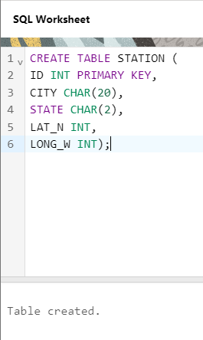

1. Insert the following records into the table:

Ans.

INSERT INTO STATION VALUES (13, 'PHOENIX', 'AZ', 33, 112);

INSERT INTO STATION VALUES (44, 'DENVER', 'CO', 40, 105);

INSERT INTO STATION VALUES (66, 'CARIBOU', 'ME', 47, 68);

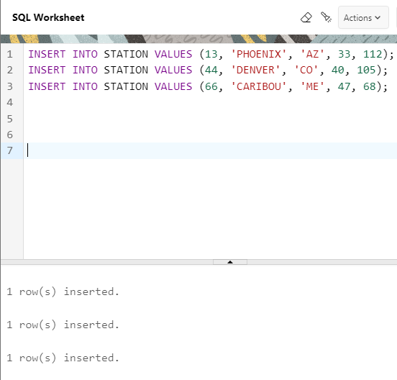

1. Execute a query to look at table STATION in undefined order.

Ans.

SELECT * FROM STATION;

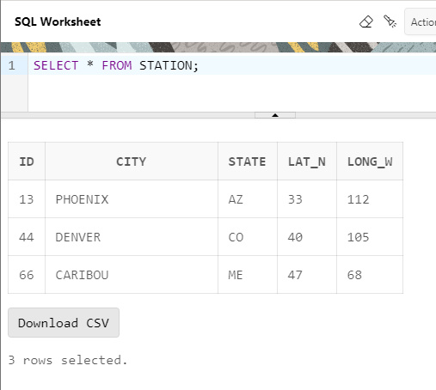

1. Execute a query to select Northern stations (Northern latitude > 39.7).

Ans.

SELECT * FROM STATION

WHERE LAT_N > 39.7;

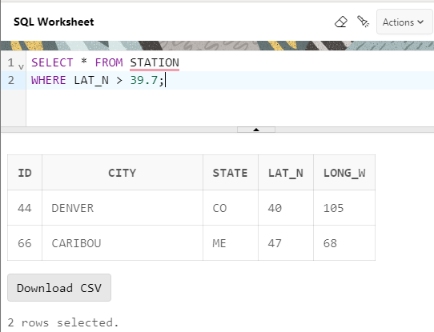

1. Create another table, ‘STATS’, to store normalized temperature and precipitation data:

Ans.

CREATE TABLE STATS(

ID INT,

"MONTH" INT CHECK ("MONTH" BETWEEN 1 AND 12),

TEMP_F DECIMAL(5, 2) CHECK (TEMP_F BETWEEN -80 AND 150),

RAIN_I DECIMAL (5, 2) CHECK (RAIN_I BETWEEN 0 AND 100),

FOREIGN KEY (ID) REFERENCES STATION(ID),

CONSTRAINT ID_MONTH UNIQUE (ID, "MONTH"));

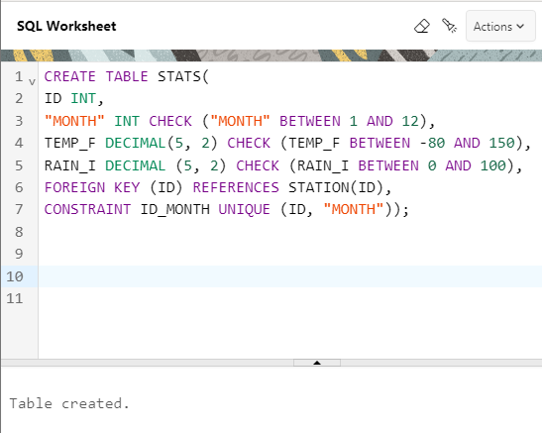

1. Populate the table STATS with some statistics for January and July:

Ans.

INSERT INTO STATS VALUES

(13, 1, 57.4, .31);

INSERT INTO STATS VALUES

(13, 7, 91.7, 5.15);

INSERT INTO STATS VALUES

(44, 1, 27.3, .18);

INSERT INTO STATS VALUES

(44, 7, 74.8, 2.11);

INSERT INTO STATS VALUES

(66, 1, 6.7, 2.1);

INSERT INTO STATS VALUES

(66, 7, 65.8, 4.52);

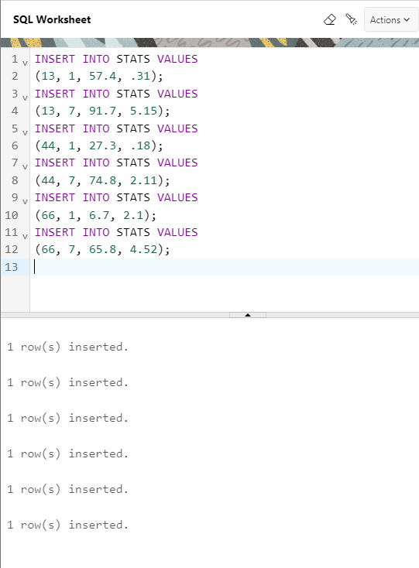

1. Execute a query to display temperature stats (from the STATS table) for each city (from the Station table).

Ans.

SELECT ST.CITY, AVG(S.TEMP_F) AS AVERAGE_TEMPERATURE, MIN(S.TEMP_F) AS MIN_TEMPERATURE, MAX(S.TEMP_F) AS MAX_TEMPERATURE

FROM STATS S

JOIN STATION ST

ON S.ID = ST.ID

GROUP BY ST.CITY;

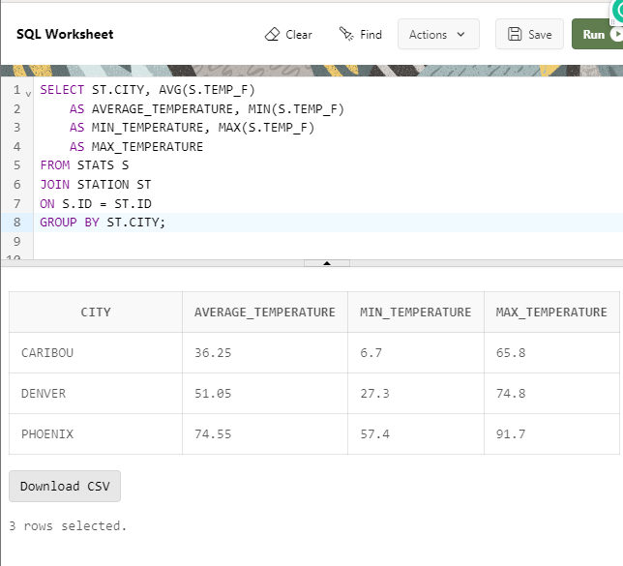

1. Execute a query to look at the table STATS, ordered by month and greatest rainfall, with columns rearranged. It should also show the corresponding cities.

Ans.

NOTE-

( The order for month and Rai_I has to be same since both follow same trend)

WORKING-

TABLES USED

FROM STATS; - MONTH, RAIN_I, (ID)

FROM STATION; - CITY, (ID)

CODE-

SELECT S."MONTH", S.RAIN_I, ST.CITY

FROM STATS S

JOIN STATION ST ON S.ID = ST.ID

ORDER BY S."MONTH" DESC, S.RAIN_I DESC;

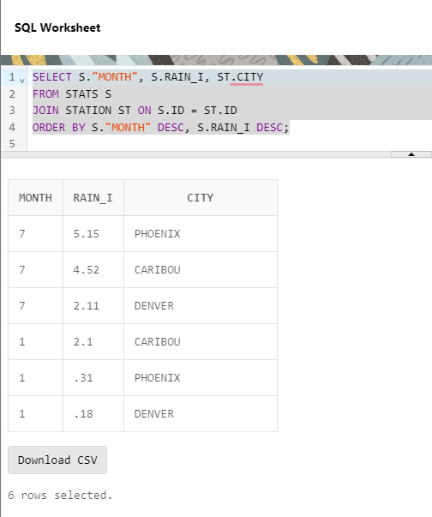

1. Execute a query to look at temperatures for July from table STATS, lowest temperatures first, picking up city name and latitude.

Ans.

WORKING-

TABLES USED

FROM STATS; - TEMP_F, MONTH -7, (ID)

FROM STATION; - CITY, LAT_N, (ID)

CODE-

SELECT S."MONTH", S.TEMP_F, ST.CITY, ST.LAT_N

FROM STATS S

JOIN STATION ST ON S.ID = ST.ID

WHERE "MONTH"=7

ORDER BY S.TEMP_F;

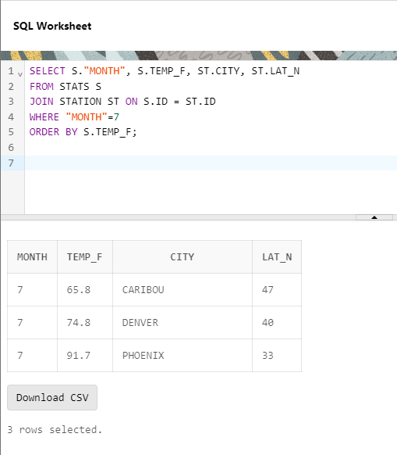

1. Execute a query to show MAX and MIN temperatures as well as average rainfall for each city.

Ans.

WORKING-

TABLES USED

FROM STATS; - TEMP_F, RAIN_I, (ID)

FROM STATION; - CITY, (ID)

CODE-

SELECT ST.CITY,

MAX(S.TEMP_F) AS MAX_TEMP,

MIN(S.TEMP_F) AS MIN_TEMP,

AVG(S.RAIN_I) AS AVERAGE_TAINFALL

FROM STATS S

JOIN STATION ST

ON S.ID = ST.ID

GROUP BY ST.CITY;

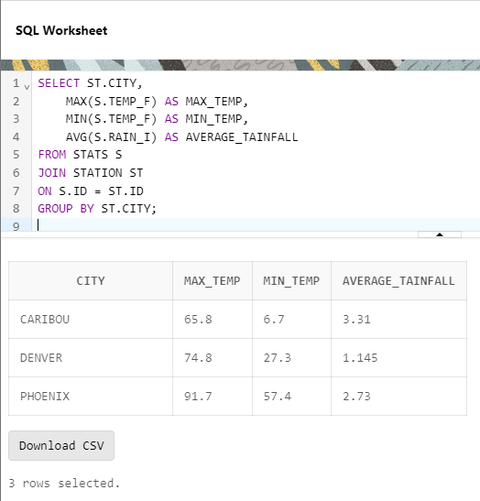

1. Execute a query to display each city’s monthly temperature in Celcius and rainfall in Centimeter.

Ans.

WORKING-

from stats- TEMP_F {FAHRENHEIT TO CELCIUS} ,

RAIN_I {INCHES TO CENTIMETER} (ID),

MONTH

from station- CITY (ID)

CODE-  
SELECT ST.CITY,

S."MONTH",

((S.TEMP_F - 32) * (5.0/9.0)) AS TEMPERATURE_C,

(S.RAIN_I * 2.54) AS RAINFALL_CM

FROM STATS S

JOIN STATION ST

ON S.ID = ST.ID;

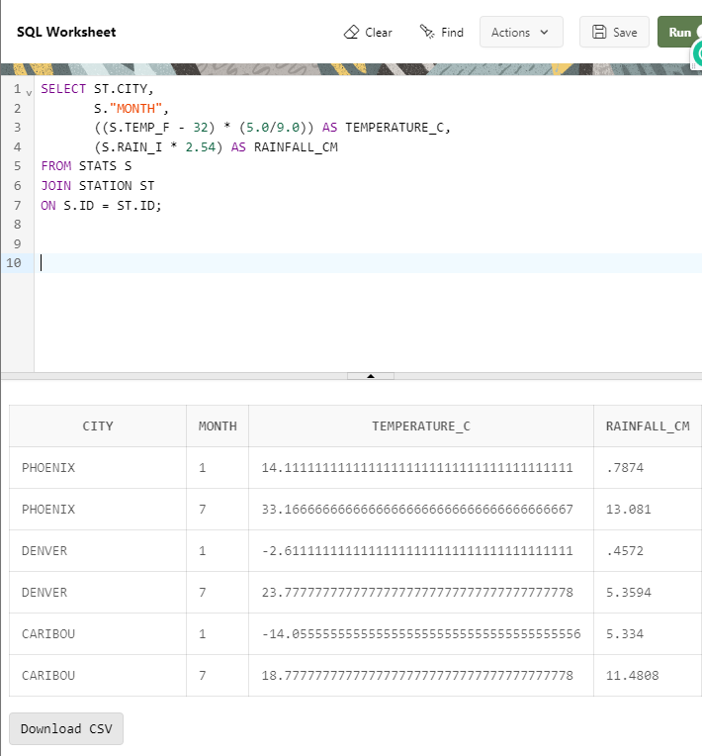

1. Update all rows of table STATS to compensate for faulty rain gauges known to read 0.01 inches low.

Ans.

UPDATE STATS

SET RAIN_I=RAIN_I + 0.01;

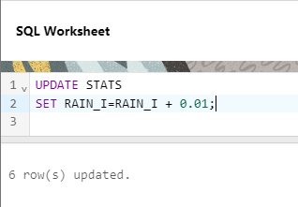

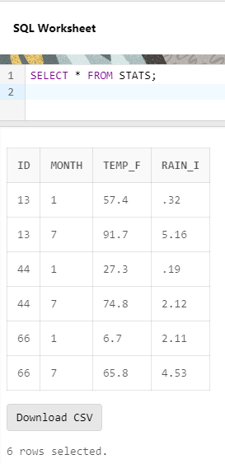

1. Update Denver's July temperature reading as 74.9

Ans.

NOTE-  
NEED TO UPDATE TEMP_F OF DENVER (7) FROM 74.8 TO 74.9

CODE-

STEP 1.

CREATE VIEW JOIN_S_ST AS

SELECT ST.CITY, S."MONTH", S.TEMP_F FROM STATS S

JOIN STATION ST

ON S.ID=ST.ID;

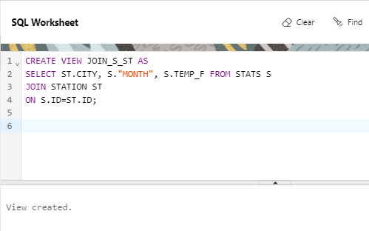

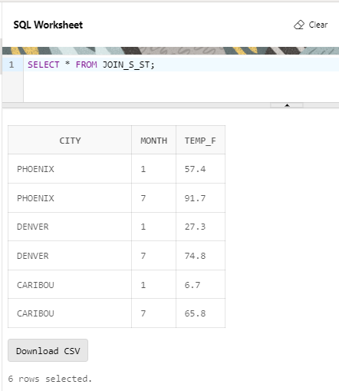

STEP 2.

UPDATE JOIN_S_ST

SET TEMP_F = 74.9

WHERE CITY = 'DENVER' AND "MONTH"=7;

